**USER INTERFACE PROTOTYPE**

PAGE 1:

Visitor’s Page:

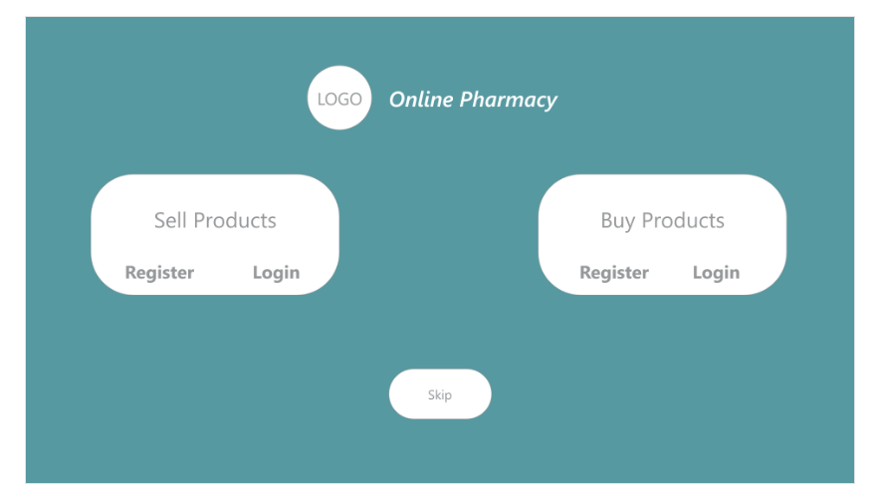

Basically, this platform is for both sellers and visitors where each gets a respective registration and login page.

The skip option is for the general visitor who just wants to look at the site without registering.

PAGE 2:

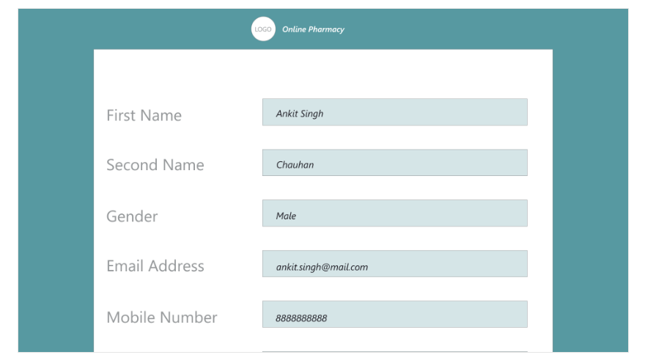

This type of form will open up if the user wants to register as a pharmacy or as a buyer (customer).

PAGE 3:

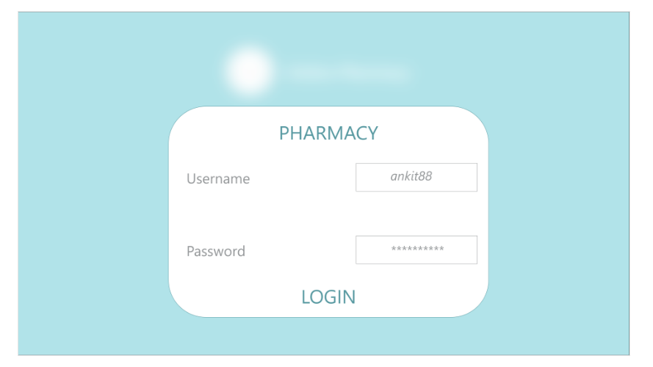

This is the login page for the pharmacy.

PAGE 4:

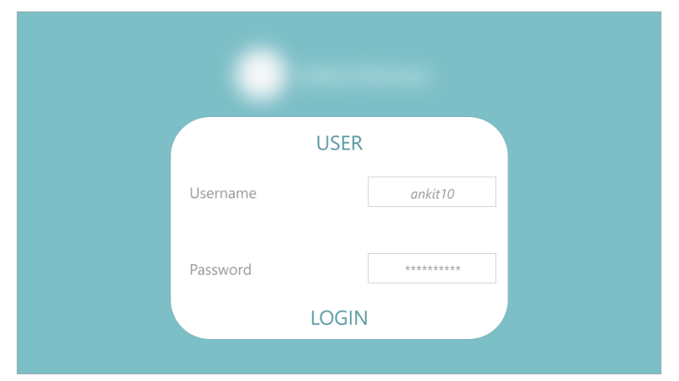

This is the login page for the buyer (customer).

PAGE 5:

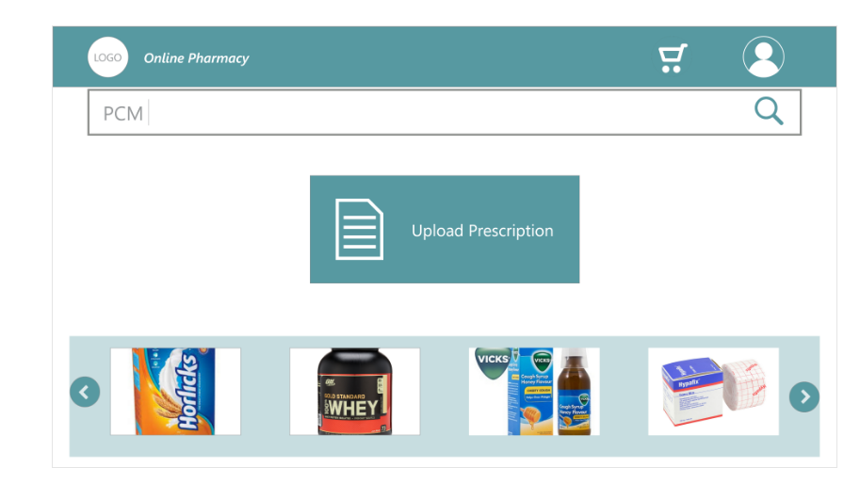

This is the customer’s dashboard where

1. On the right side there are two options profile and cart.
2. There is a search bar given to search for the OTC products.
3. If a customer wants to buy NON-OTC product , he/she has been given an option to upload the prescription.

#4)??

PAGE 6:

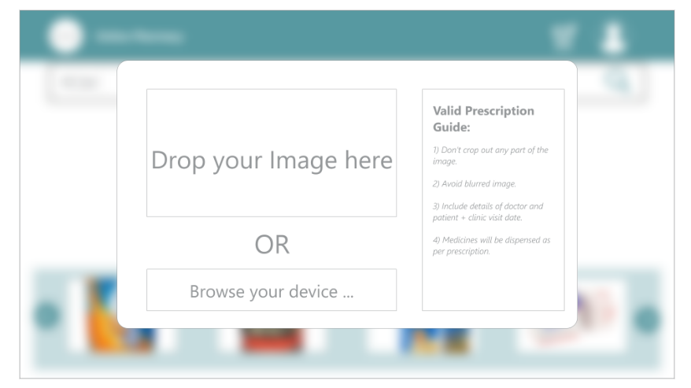

This page would appear when the user selects the upload prescription on the previous page.

PAGE 7:

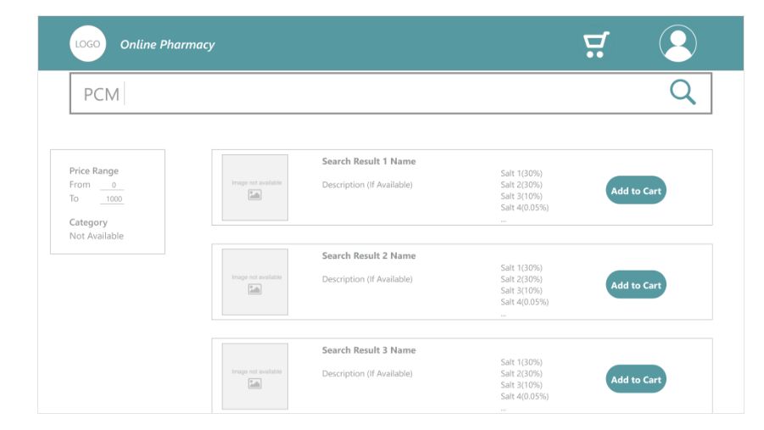

This page would come when a user searches for a product (OTC).

The page shows all the related results that came on searching a particular product.

PAGE 8:

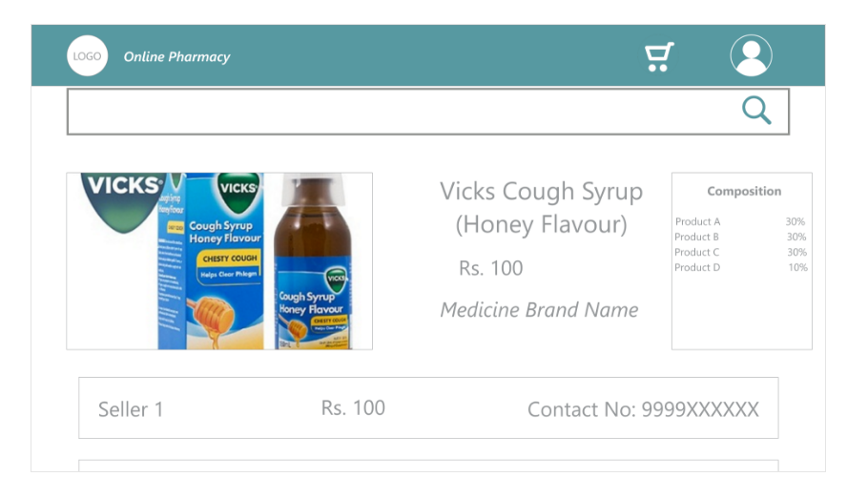

When we select a particular product from the above list, this page will pop up and this contains the 5-6 pharmacies according to our algorithm selling this product.

PAGE 9:

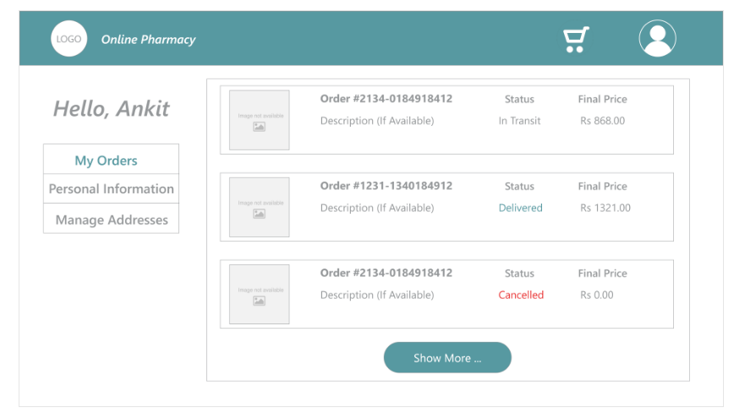

This page shows a look how will the page look like when my profile icon on the top right is clicked.

This page is showing the order history.

PHARMACY END:

PAGE 10:

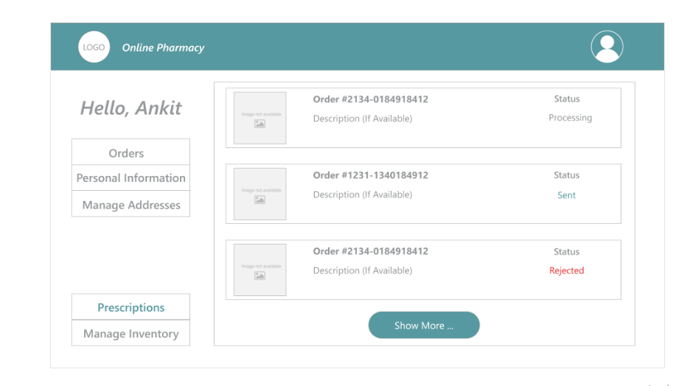

This page displays the dashboard for the pharmacy.

# PAGE 11:

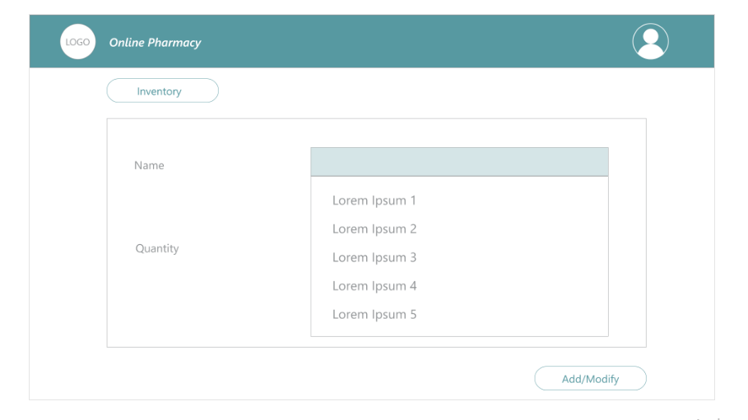

PAGE 12:

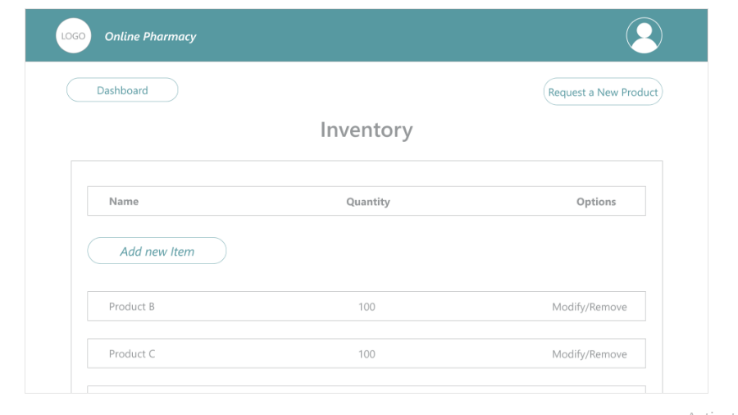

This page is for the pharmacist where he/she can monitor his /her inventory.

PAGE 13:

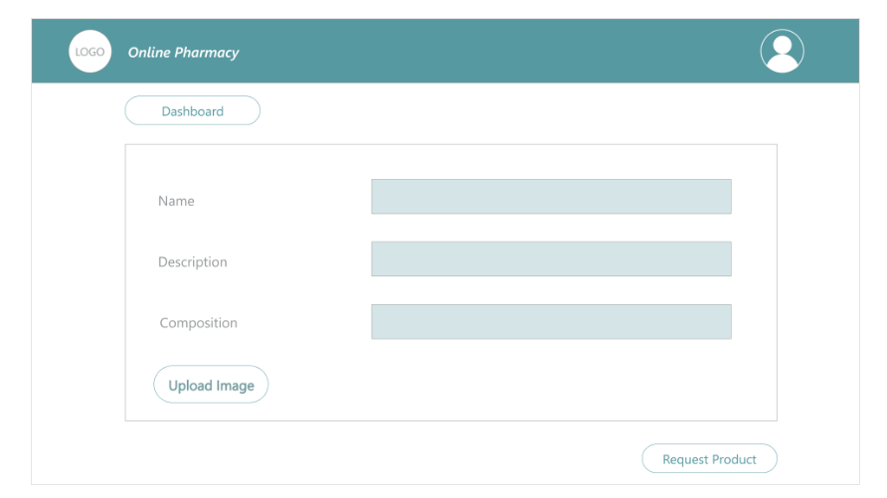

This is the form which will open up once a pharmacist wants to add a new product to his/her inventory.